**WASHPLUS WASHING MACHINE USER MANUAL**

**TABLE OF CONTENT**

1. **BEFORE USING THE WASHING MACHINE---(Page 2)**
   1. **SAFETY INSTRUCTIONS**
   2. **PERMITTED USE**
   3. **INSTALLATION**
2. **PRODUCT DESCRIPTION---(Page 3-4)**
   1. **MODEL NUMBER AND ITS SPECIFICATIONS.**
   2. **FEATURES**
   3. **CONTROL PANEL**
   4. **PROGRAMS**
   5. **FUNCTIONS**
3. **HOW TO USE WASHING MACHINE---(Page 4-5)**
4. **CLEANING THE WASHING MACHINE---(Page 4-5)**
   1. **CLEANING OUTER PART OF THE MACHINE**
   2. **CLEANING INNER PART OF THE MACHINE**
5. **TROUBLESHOOTING---(Page 5)**

**Thanks for buying a whirlpool product. To know more about product register your product on** [**www.washplus.eu/register**](http://www.washplus.eu/register)

1. **BEFORE USING THE WASHING MACHINE**

Before using the appliance, read these safety instructions. Keep them handy for the future reference. The manufacturer declines any liability for failure to observe these safety instructions, for inappropriate use of the appliance or incorrect setting of controls.

* 1. **Safety Instruction**
* Young children of age 0 – 5 years should be kept away from the appliance unless continuously supervised.
* Children should not play with the appliance.
* Never open the machine’s door forcibly. If locked take assistance from our team.
* Make sure the application is installed in the proper electrical connections and water supply.
  1. **Permitted Use**
* The appliance is not intended to be operated by means of external switching device.
* The appliance is intended to be used in the household area or similar applications such as : Staff kitchen areas, shops, working environments, hotels, motels and other residential environments.
* The appliance is strictly intended for indoor use. It is not for professional use.
* Keep the detergents mixed with any flammable solvents away from the machine. Do not wash any fabrics which have been treated with solvents and flammable liquids.
  1. **Installation**
* Two or more persons are advised to handle the machine at the time of installation in order to reduce the risk of injury.
* Use protective gloves to unpack and install the appliance this will reduce the risk of cuts.
* Do not lift the appliance to move. Use worktop or top lid.
* Installation, water supply and electrical connections must be carried out by qualified technician.
* Disconnect the appliance from the power supply before any installation operation - risk of electric shock
* During installation, make sure the appliance does not damage the power cable - risk of fire or electric shock.
* Install the appliance with the proper ventilation and temperature above 6 degrees Celsius or below 35 degrees Celsius.
* Make sure that the ventilation openings in the base of your washing machine (if available on your model) are not obstructed by a carpet or other material.

1. 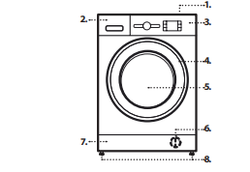**PRODUCT DESCRIPTION**
2. worktop
3. Detergent Dispenser
4. Control Panel
5. Door Handle
6. Door
7. Water Filter - behind plinth
8. Plinth
9. Adjustable Feet

**2.1 Detergent Dispenser**

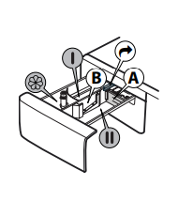**Main wash compartment**

• Detergent for the main wash

• Stain remover

• Water softener

• For a liquid detergent it is recommended to use removable plastic partition A (supplied) for a proper dosage. If powder detergent is used, place the partition into slot B.

**Prewash compartment**

• Detergent for the prewash

**Softener compartment**

• Fabric softener

• Liquid starch Pour softener or starch solution only up to the “MAX” mark.

**Release button δ (press to remove and clean the dispenser)**

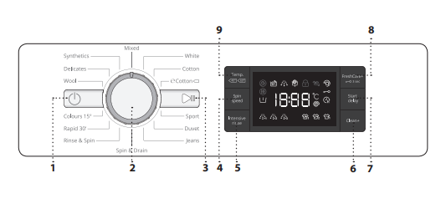  
**2.2) Control Panel**

1. “ON/OFF” Button
2. “Programme Selector” Button
3. “Start/Pause” Button
4. “Spin” Button
5. “Intensive Rinse” Button
6. “Clean+” Button
7. “Start Delay” Button
8. “Fresh Care+” Button
9. “Temperature” Button

**2.3) Functions**

** ON/OFF**

To switch on the washing machine: press the “ON/OFF“ button, the “Start/Pause” button light up. To switch off the washing machine during the wash cycle, press and hold the button for approximately 3 seconds. If the button is pressed briefly or accidentally the machine will not switch off. To switch off the washing machine after programme end: press the “ON/OFF“ button until the lights go off.

**KNOB**To select the programme, rotate and select.

**START/PAUSE**

To start the selected programme after you finish your settings, to pause a selected programme. To continue a paused programme.

**KEY LOCK**



To lock the control panel, press and hold the “Key Lock button” for approximately 3 seconds. The symbol “” will lightup and control panel will be locked. Similarly to unlock the control panel, press and hold the “key lock” button for approximately 3 seconds.

1. **HOW TO USE THE APPLIANCE**

**Preparing for Laundry:**

* Empty all the pockets of the clothes
* Lock the zips and tie the belts of the clothes to be washed
* Do not forget to check the fabric type and the programme.
* **Load laundry** – Open the door, load the laundry. Do not overload the drum. Overloading will result in unsatisfactory results.
* **Close the door** – Make sure no laundry gets stuck in the door. Close the door properly.
* **Open the water tap** - Make sure that the washing machine is connected to the water mains. Open the water tap
* **Add detergent** – Pull the dispenser and add the detergent into the relative compartments. Add the correct dosage of detergent as recommended on the detergent pack.
* Switch on the machine by pressing the ON/OFF button.
* Set the desired programme by rotating the knob.
* Press the start/pause button. Once washed the machine will beep the alarm “END” will display on the panel.
* Switch OFF the machine. Open the door, pull the washed clothes out of the drum. Leave the door ajar open to let the interior of the machine dry.

1. **HOW TO CLEAN THE WASHING MACHINE**
2. **Cleaning Outside Of The Machine**

Use a soft damp cloth to clean the outer parts of the washing machine. Do not use glass or general purpose cleaners, scouring powder or similar to clean the control panel – these substances might damage the printing.

1. **Cleaning Inner Part Of The Machine**

B.1) Cleaning the Detergent Dispenser.

Detach the detergent dispenser by pressing on the release button and at the same time pulling out the detergent dispenser.

B.2) Remove the insert from the softener compartment.

B.3) Clean all parts under running water, removing all detergent or softener residues.

B.4) Separate the parts and clean and dry the parts with soft cloth.

B.5) Reinstall the detergent Dispenser by pushing it back.

**5. TROUBLESHOOTING**

|  |  |
| --- | --- |
| Anomalies: | Possible causes / Solution: |
| The washing machine does not turn on. | * The plug is not inserted into the electrical outlet, or not enough to make contact. * There has been a power failure * The door is improperly shut. |
| The wash cycle does not start. | * The “ON/OFF” button has not been pressed. * The “Start/Pause” button has not been pressed. * The water tap is not open. * A “Start delay” has been set. |
| The washing machine does not drain or does not spin. | * The programme does not include the draining function: with certain programmes it must be activated manually. * The drain hose is bent. * The drain line is obstructed |
| Door is locked, with or without failure indication, and the programme does not run. | * Door is locked in case of power breakdown. Programme will continue automatically as soon as the mains is available again. * Washing machine is in a standstill. Programme will continue automatically after the origin of the standstill does not persist anymore. |